**Name: Mozeb Ahmed Khan**

**Roll No: 20F-0161**

**Sec: BS (CS)-7A**

**Assignment: 03**

**Course: Applied Machine Learning**

**Question 1: Bayes Theorem**

1. **A medical test for a disease D has outcomes + and −. The probabilities are:**

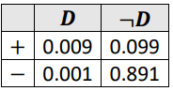

**What is the probability that the test will return a positive result for a sick person? If you go for a test and get a positive, what is the probability that you have the disease D?**

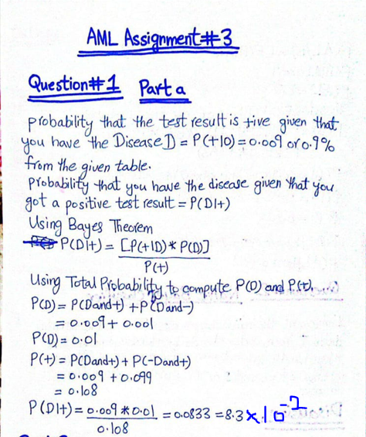

1. **Suppose you divide your email into three categories: A1 = spam, A2 =low priority, A3 =high priority. From previous experience you know that P(A1) = 0.7, P(A2) = 0.2, P(A3) = 0.1. Let B be the event that the email contains the word “free”. What is the probability that it is spam?**

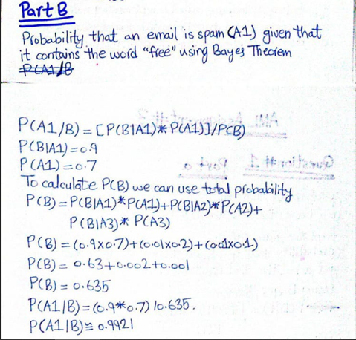

**Question 2: Naïve Bayes Classifier**

**Implement the naïve bayes classifier on the following dataset. Your code should be flexible enough that may handle such types of data with different number of examples or the variable with different values.**

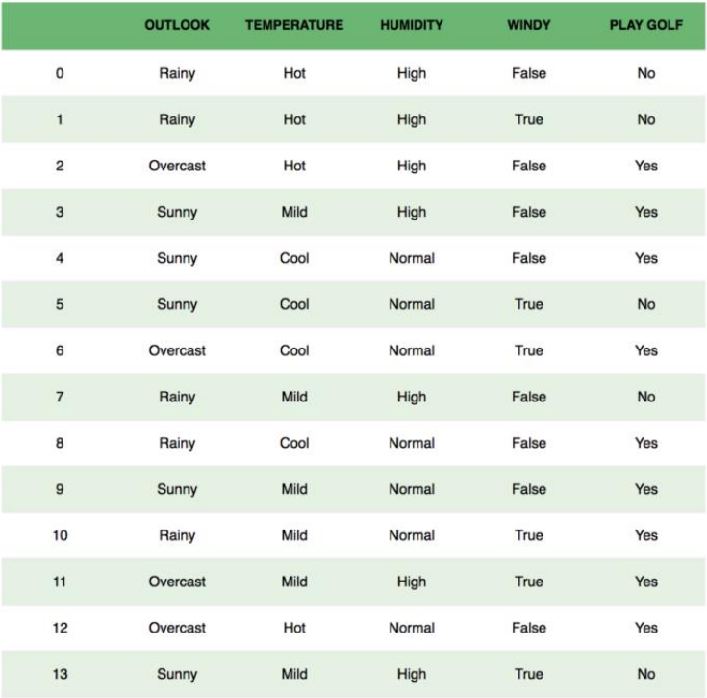

**Code:**

class NaiveBayesClassifier:

    def __init__(self):

        # Initialize dictionaries to store probabilities

        self.probabilities_class = {}  # P(Play Golf = Yes), P(Play Golf = No)

        self.probabilities_feature = {}  # P(Outlook | Play Golf), P(Temperature | Play Golf), ...

    def fit(self, data, labels):

        # Calculate class probabilities

        total_samples = len(labels)

        unique_classes, class_counts = self.calculate_counts(labels)

        for i, class_label in enumerate(unique_classes):

            # Calculate P(Play Golf = Yes) and P(Play Golf = No)

            self.probabilities_class[class_label] = class_counts[i] / total_samples

        # Calculate feature probabilities

        features = list(data.keys())

        for feature in features:

            # Find unique values for each feature

            unique_values = self.get_unique_values(data[feature])

            self.probabilities_feature[feature] = {}

            for class_label in unique_classes:

                self.probabilities_feature[feature][class_label] = {}

                for value in unique_values:

                    # Calculate P(feature = value | Play Golf)

                    count = self.calculate_feature_count(data[feature], value, labels, class_label)

                    total_count = self.calculate_total_count(labels, class_label)

                    self.probabilities_feature[feature][class_label][value] = count / total_count

    def predict(self, sample):

        # Predict the class for a new sample

        predictions_class = {}

        for class_label, class_prob in self.probabilities_class.items():

            feature_prob_product = 1.0

            for feature, value in sample.items():

                # Multiply the probabilities for each feature value

                feature_prob_product *= self.probabilities_feature[feature][class_label].get(value, 0.0)

            # Store the final probability for each class

            predictions_class[class_label] = class_prob * feature_prob_product

        # Return the class with the highest probability

        return max(predictions_class, key=predictions_class.get)

    def calculate_counts(self, labels):

        # Calculate the count of each class in the dataset

        unique_classes, class_counts = [], []

        for label in labels:

            if label not in unique_classes:

                unique_classes.append(label)

                class_counts.append(1)

            else:

                index = unique_classes.index(label)

                class_counts[index] += 1

        return unique_classes, class_counts

    def calculate_feature_count(self, feature_values, value, labels, class_label):

        # Calculate the count of a specific feature value for a given class

        count = 0

        for i in range(len(labels)):

            if feature_values[i] == value and labels[i] == class_label:

                count += 1

        return count

    def calculate_total_count(self, labels, class_label):

        # Calculate the total count of a specific class in the dataset

        count = 0

        for label in labels:

            if label == class_label:

                count += 1

        return count

    def get_unique_values(self, values):

        # Find unique values for a feature

        unique_values = []

        for value in values:

            if value not in unique_values:

                unique_values.append(value)

        return unique_values

# Example dataset

new_data = {

    'Outlook': ['Rainy', 'Rainy', 'Overcast', 'Sunny', 'Sunny', 'Sunny', 'Overcast', 'Rainy', 'Rainy', 'Sunny', 'Rainy', 'Overcast', 'Overcast', 'Sunny'],

    'Temperature': ['Hot', 'Hot', 'Hot', 'Mild', 'Cool', 'Cool', 'Cool', 'Mild', 'Cool', 'Mild', 'Mild', 'Mild', 'Hot', 'Mild'],

    'Humidity': ['High', 'High', 'High', 'High', 'Normal', 'Normal', 'Normal', 'High', 'Normal', 'Normal', 'Normal', 'High', 'Normal', 'High'],

    'Windy': ['False', 'True', 'False', 'False', 'False', 'True', 'True', 'False', 'False', 'False', 'True', 'True', 'False', 'True'],

    'Play Golf': ['No', 'No', 'Yes', 'Yes', 'Yes', 'No', 'Yes', 'No', 'Yes', 'Yes', 'Yes', 'Yes', 'Yes', 'No']

}

# Instantiate and train the Naive Bayes classifier

nb_classifier = NaiveBayesClassifier()

nb_classifier.fit(new_data, new_data['Play Golf'])

# Test the classifier with a new sample

new_sample = {'Outlook': 'Rainy', 'Temperature': 'Cool', 'Humidity': 'High', 'Windy': 'True'}

prediction = nb_classifier.predict(new_sample)

# Display new sample and predicted class in tabular form

print("New Sample:")

print(f"{'Feature':<12} {'Value':<12}")

print("----------------------")

# Print feature-value pairs in tabular form

for feature, value in new_sample.items():

    print(f"{feature:<12} {value:<12}")

# Display predicted class

print(f"\nPredicted class: {prediction}")

**Output:**

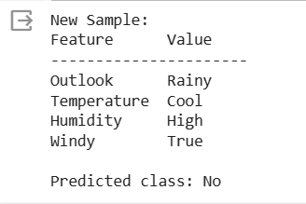

**Question 3: K-mean and K-medoid Clustering**

**Load the dataset available in the folder with the name “dataset” where there are four features A1, A2, A3, and A4. Your task is to implement the following,**

1. **K-mean clustering algorithm on the given dataset when the value for K is user-defined, that may be 2, 3, or 4, etc.**
2. **K-mediod clustering algorithm on the given dataset when the value for K is user-defined, that may be 2, 3, or 4, etc.**
3. **For visualization of the cluster, draw a scatter plot of the dataset and assign colors based on clusters computed through K-means and K-mediod methods.**

**Code:**

import pandas as pd

import numpy as np

import matplotlib.pyplot as plt

# Define the K-means clustering algorithm

class MyKMeans:

    def __init__(self, num_clusters):

        # Initialize clusters

        self.num_clusters = num_clusters

        self.centroids = None

    def fit(self, input_data):

        # Initialize centroids randomly

        self.centroids = input_data[np.random.choice(input_data.shape[0], self.num_clusters, replace=False)]

        while True:

            # Assign each data point to the nearest centroid

            labels = self.assign_labels(input_data)

            # Update centroids based on the mean of assigned data points

            new_centroids = np.array([input_data[labels == i].mean(axis=0) for i in range(self.num_clusters)])

            # Check for convergence

            if np.all(new_centroids == self.centroids):

                break

            self.centroids = new_centroids

        return labels

    def assign_labels(self, input_data):

        # Calculation of distances between data points and centroids

        distances = np.array([[np.linalg.norm(point - centroid) for centroid in self.centroids] for point in input_data])

        # Assign labels by selecting the centroid index with the minimum distance for each data point

        labels = np.argmin(distances, axis=1)

        return labels

# Define the K-medoids clustering algorithm

class MyKMedoids:

    def __init__(self, num_clusters):

        # Initialize clusters

        self.num_clusters = num_clusters

        self.medoids = None

    def fit(self, input_data, max_iter=100):

        num_samples, num_features = input_data.shape

        # Initialize medoids randomly

        self.medoids = input_data[np.random.choice(num_samples, self.num_clusters, replace=False)]

        for _ in range(max_iter):

            # Assign each data point to the nearest medoid

            labels, distances = self.calculate_pairwise_distances(input_data)

            # Update medoids based on the total distance to other data points

            new_medoids = np.array([input_data[labels == i][np.argmin(distances[labels == i])] for i in range(self.num_clusters)])

            # Check for convergence

            if np.all(new_medoids == self.medoids):

                break

            self.medoids = new_medoids

        return labels

    def calculate_pairwise_distances(self, input_data):

        # Calculation of pairwise distances between data points and medoids

        distances = np.array([[np.linalg.norm(point - medoid) for medoid in self.medoids] for point in input_data])

        # Find the index of the medoid with the minimum distance for each data point

        labels = np.argmin(distances, axis=1)

        # Find the minimum distances from each data point to its nearest medoid

        min_distances = np.min(distances, axis=1)

        return labels, min_distances

# Load the dataset

dataset = pd.read_excel("dataset.xlsx").values

# Get user-defined value for K

num_clusters_value = int(input("Enter the number of clusters (K): "))

# Apply K-means clustering

kmeans = MyKMeans(num_clusters=num_clusters_value)

kmeans_labels = kmeans.fit(dataset)

# Apply K-medoids clustering

kmedoids = MyKMedoids(num_clusters=num_clusters_value)

kmedoids_labels = kmedoids.fit(dataset)

# Visualize the clusters with different colors

plt.scatter(dataset[:, 0], dataset[:, 1], c=kmeans_labels, cmap='Set1', label='K-means')

plt.scatter(kmeans.centroids[:, 0], kmeans.centroids[:, 1], c='red', marker='X', label='K-means centroids')

plt.scatter(dataset[:, 0], dataset[:, 1], c=kmedoids_labels, cmap='Set2', label='K-medoids')

plt.scatter(kmedoids.medoids[:, 0], kmedoids.medoids[:, 1], c='green', marker='X', label='K-medoids medoids')

plt.title(f'K-means and K-medoids Clustering (K={num_clusters_value})')

plt.xlabel('Feature A1')

plt.ylabel('Feature A2')

plt.legend()

plt.show()

**Output:**

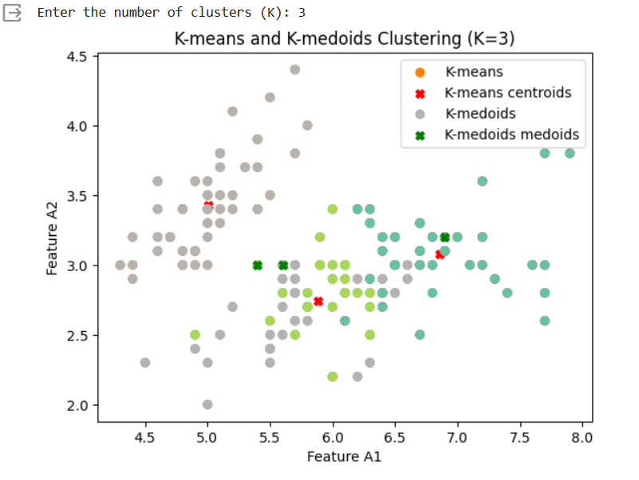

**The End.**

**Thank You.**